EX7.3
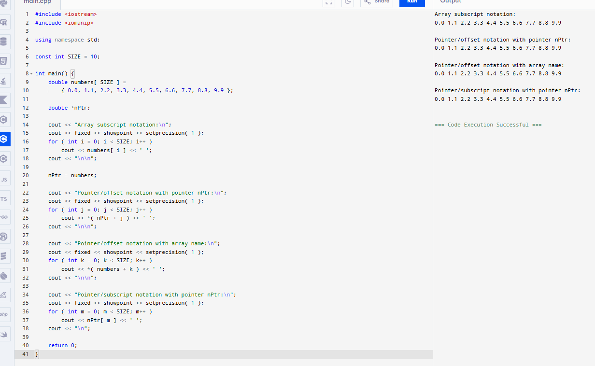
#include <iostream>
#include <iomanip>

using namespace std;

const int SIZE = 10;

int main() {
double numbers[ SIZE ] =
{ 0.0, 1.1, 2.2, 3.3, 4.4, 5.5, 6.6, 7.7, 8.8, 9.9 };

double *nPtr;

cout << "Array subscript notation:\n";
cout << fixed << showpoint << setprecision( 1 );
for ( int i = 0; i < SIZE; i++ )
cout << numbers[ i ] << ' ';
cout << "\n\n";

nPtr = numbers;

cout << "Pointer/offset notation with pointer nPtr:\n";
cout << fixed << showpoint << setprecision( 1 );
for ( int j = 0; j < SIZE; j++ )
cout << *( nPtr + j ) << ' ';
cout << "\n\n";

cout << "Pointer/offset notation with array name:\n";
cout << fixed << showpoint << setprecision( 1 );
for ( int k = 0; k < SIZE; k++ )
cout << *( numbers + k ) << ' ';
cout << "\n\n";

cout << "Pointer/subscript notation with pointer nPtr:\n";
cout << fixed << showpoint << setprecision( 1 );
for ( int m = 0; m < SIZE; m++ )
cout << nPtr[ m ] << ' ';
cout << "\n";

return 0;
}
EX7.4
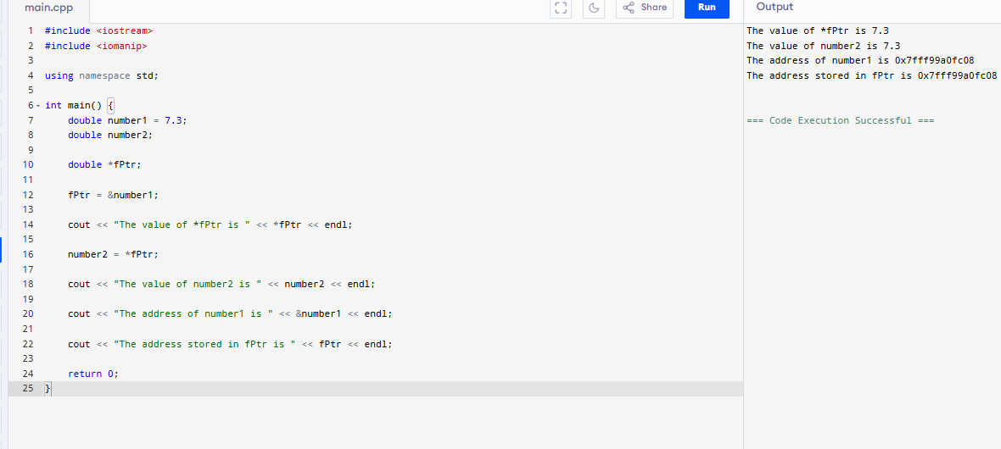
#include <iostream>
#include <iomanip>

using namespace std;

int main() {
double number1 = 7.3;
double number2;

double *fPtr;

fPtr = &number1;

cout << "The value of *fPtr is " << *fPtr << endl;

number2 = *fPtr;

cout << "The value of number2 is " << number2 << endl;

cout << "The address of number1 is " << &number1 << endl;

cout << "The address stored in fPtr is " << fPtr << endl;

return 0;
}

